F1
PIT STOP STRATEGY INTELLIGENCE SYSTEM
A Multi-Layered Machine Learning & Statistical Framework

for Formula 1 Race Strategy Prediction and Analysis

Nguyen Tri
June 2026
Metric | Value
Training Seasons | 7 (2018–2024)
Total Laps Processed | 152,475
Pit Stop Events | 4,818 (~3.16% of laps)
BiLSTM Layers | 3 Bidirectional
Sequence Length | 20 laps / window
Engineered Features | 40+ dimensions
Pipeline Modules | 5 integrated scripts
Model Confidence on Pit Laps | 83.8%

01 — Executive Summary
This report documents the design, implementation, and outcomes of a comprehensive data science project to model and predict Formula 1 pit stop strategies using machine learning, survival analysis, and classical statistics. Built on 2018–2025 race data sourced via the FastF1 API and the Ergast historical database, the system integrates five tightly coupled modules spanning deep learning sequence modelling, stochastic hazard modelling, strategic regression, overtake classification, and descriptive analytics.
The core deliverable is a three-layer Bidirectional LSTM (BiLSTM) neural network that ingests 20-lap sliding windows of race telemetry and outputs the probability of a pit stop on the final lap of each window. Downstream modules consume those probabilities to classify overtakes as strategic or on-track, quantify team risk tolerance, evaluate tactical agility under Virtual Safety Car (VSC) events, and test whether faster pit crews earn statistically more championship points.
Key Result: The trained BiLSTM model assigns a mean confidence of 83.8% on laps where a pit stop actually occurred — compared to a near-zero baseline on non-pit laps — demonstrating strong discriminative capability despite a 3.16% positive class rate.

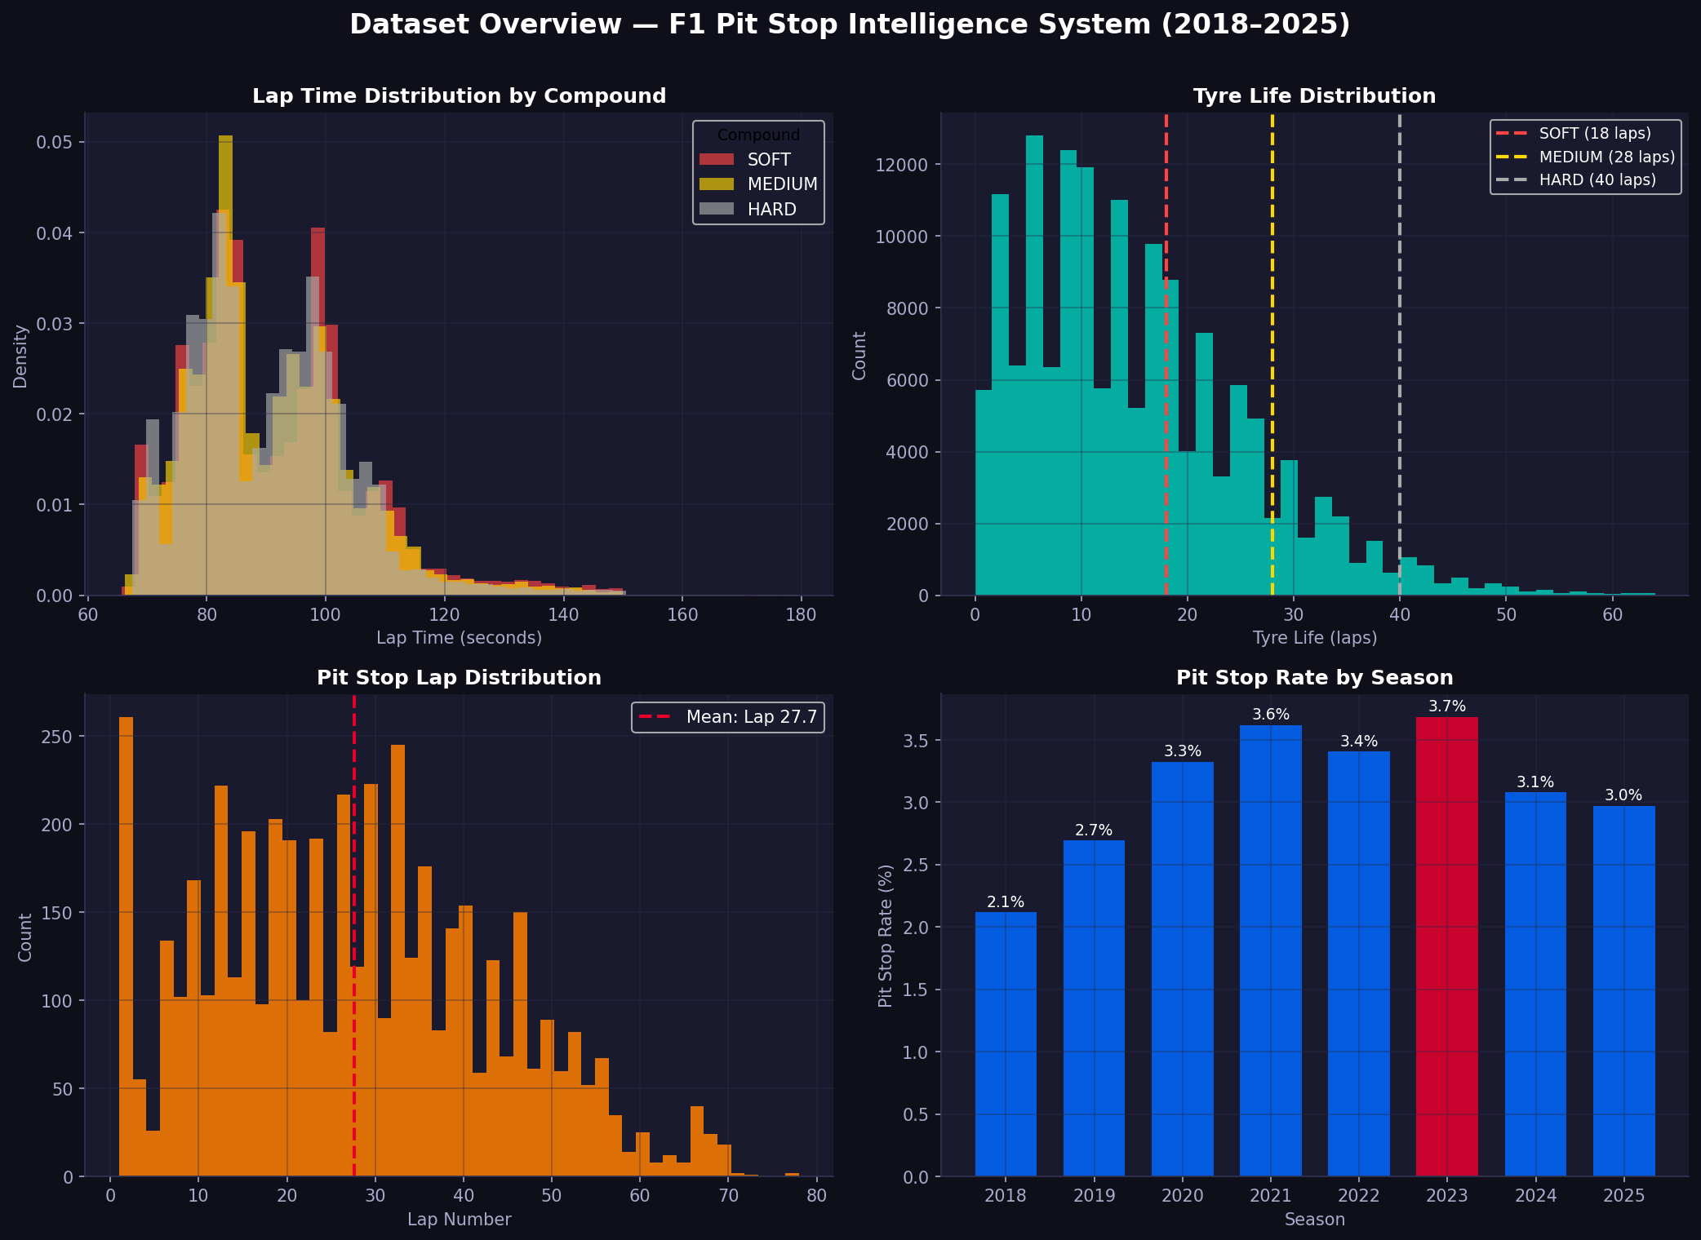
Figure 1: Dataset overview — lap time distributions by compound, tyre life, pit stop lap distribution, and seasonal pit stop rates (2018–2025).

02 — Project Overview & Motivation
Formula 1 strategy is decided in the pitlane. The decision to pit — when, on what compound, and in reaction to what on-track event — routinely separates podiums from points finishes. A model that assigns real-time probabilities to imminent pit stops enables: earlier undercut detection, smarter tyre compound selection, better VSC window exploitation, and data-driven post-race debriefs.

Research Objectives
- Can a sequence model trained on historical lap telemetry predict pit stop events with clinically useful precision and recall?
- Which stochastic process best characterises the hazard of pitting as tyre age increases?
- Is there a statistically significant relationship between pit crew speed and constructor championship performance?
- Can a driver's reaction time to VSC events predict whether they finish above their qualifying grid position?

Data Sources
Source | Coverage | Usage
FastF1 API | 2018–2025 GP races | Lap telemetry — speed, RPM, throttle, brake, DRS, tyre compound & age
Ergast API | Full F1 history | Pit stop durations, constructor IDs, driver standings, race results
Preprocessed CSVs | All sessions | 40+ features per lap in all_training_data.csv

03 — Data Pipeline & Feature Engineering

Download & Caching (download.py)
The download module iterates over every race in the specified season range using the FastF1 event schedule, skipping testing events and previously downloaded sessions via a file-existence checkpoint. Three CSV files are written per Grand Prix — race results, lap data, and full telemetry. A polite 3-second delay between sessions prevents HTTP 429 rate-limit errors from the API.

Feature Engineering
Feature Group | Examples | Rationale
Race State | LapNumber, Position, TrackStatus | Contextualise strategic windows
Tyre Degradation | TyreLife, tire_performance_decay, relative_tire_age | Primary pit trigger signal
Pace Evolution | delta_laptime, rolling_pace_mean_5, pace_degradation_slope | Detect compound cliff edge
Telemetry | Speed_mean/max/std, RPM, Throttle, Brake, DRS, nGear | Physical car load indicators
Traffic & DRS | DistanceToDriverAhead, traffic_pressure, drs_dependency | Undercut opportunity signals
Strategy Priors | historical_pit_lap, pit_window_delta | Historical compound-team norms

Leakage Prevention
Raw time columns (PitInTime, PitOutTime, LapTime, Sector1-3Time, SessionTime) are dropped before any modelling. The historical_pit_lap feature is derived exclusively from the training split and propagated to the test set via a merge — ensuring no future information contaminates predictions for the held-out year.

Class Imbalance
Pit stops occur on approximately 3.16% of laps (4,818 out of 152,475), creating severe class imbalance. The training loss function (BCEWithLogitsLoss) is weighted by the ratio of negative to positive labels. The decision threshold is selected by maximising the F1-Score across the full precision-recall curve rather than defaulting to 0.5.

04 — Core Deep Learning Model

Architecture: Three-Layer Bidirectional LSTM
The F1PitStopPredictor processes sequences of shape (batch, 20, features). Bidirectional LSTMs capture both forward and backward temporal dependencies — how this lap relates to historical context and what follows in memory. Three stacked BiLSTM layers progressively compress the representation before dense classification.

Layer | Input Dim | Hidden Size | Output Dim | Dropout
BiLSTM-1 | D (features) | 256 | 512 | 0.20
BiLSTM-2 | 512 | 128 | 256 | 0.30
BiLSTM-3 | 256 | 64 | 128 | 0.30
FC-1 (Dense) | 128 | — | 64 | 0.20
FC-2 (Dense) | 64 | — | 32 | —
Output (Sigmoid) | 32 | — | 1 (probability) | —

Training Configuration
Hyperparameter | Value | Justification
Optimiser | Adam | Adaptive learning rate for sparse gradients
Learning Rate | 1e-4 | Conservative starting point for sequence tasks
LR Scheduler | ReduceLROnPlateau (patience=4, factor=0.5) | Halves LR when AUC-PR stalls
Loss Function | BCEWithLogitsLoss + pos_weight | Numerically stable; handles class imbalance
Primary Metric | AUC-PR | Appropriate for imbalanced binary classification
Early Stopping | patience=8 on AUC-PR | Prevents overfitting on held-out year
Batch Size | 64 (train) / 256 (inference) | Stable gradient estimates
Max Epochs | 50 | Sufficient with early stopping
Train/Test Split: All seasons prior to 2025 form the training set; 2025 is the held-out test set. This temporal split simulates real-world deployment where the model must generalise to a completely unseen season.

05 — Inference & Probability Generation
The predict_pit_probabilities.py module loads best_f1_model.pt and runs inference across the entire dataset. For every valid 20-lap window per driver per race, it computes a PitStopProbability score in [0, 1]. Rows corresponding to the first 19 laps of a stint receive a default probability of 0.0.
Probabilities are mapped back to the original DataFrame using a saved array of row indices (original_row_id), avoiding positional alignment bugs from sorting or groupby reordering. The enriched dataset is saved back to all_training_data.csv.

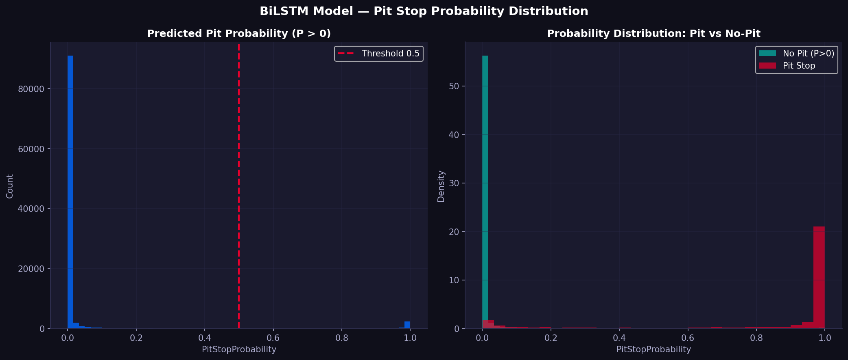
Figure 2: BiLSTM model output — pit probability distribution (left) and probability separated by actual pit stop outcome (right). Mean confidence of 83.8% on true pit laps.

06 — Stochastic & Survival Modelling

6.1 Time Series Analysis — PACF & AR(1) Filtering
Raw lap times are non-stationary: they drift downward as fuel load decreases and upward as tyres degrade. The Partial Autocorrelation Function (PACF) is computed per stint to identify the dominant lag structure. An AR(1) first-difference filter (ΔXₜ = Xₜ − Xₜ₋₁) produces a stationary Stationary_PaceDecay series isolating genuine tyre-induced degradation from traffic noise.

6.2 Hazard Modelling — Cox Proportional Hazards
Pit stops are modelled as a survival system: at each lap, a driver faces a hazard h(t) of stopping. The Cox Proportional Hazards model (lifelines library) is fitted on stint-level observations, treating TyreLife as the duration column and HasPitStop as the event indicator. Covariates include Stationary_PaceDecay and traffic_pressure. The partial hazard is min-max normalised to produce a per-lap Pit_Probability baseline.

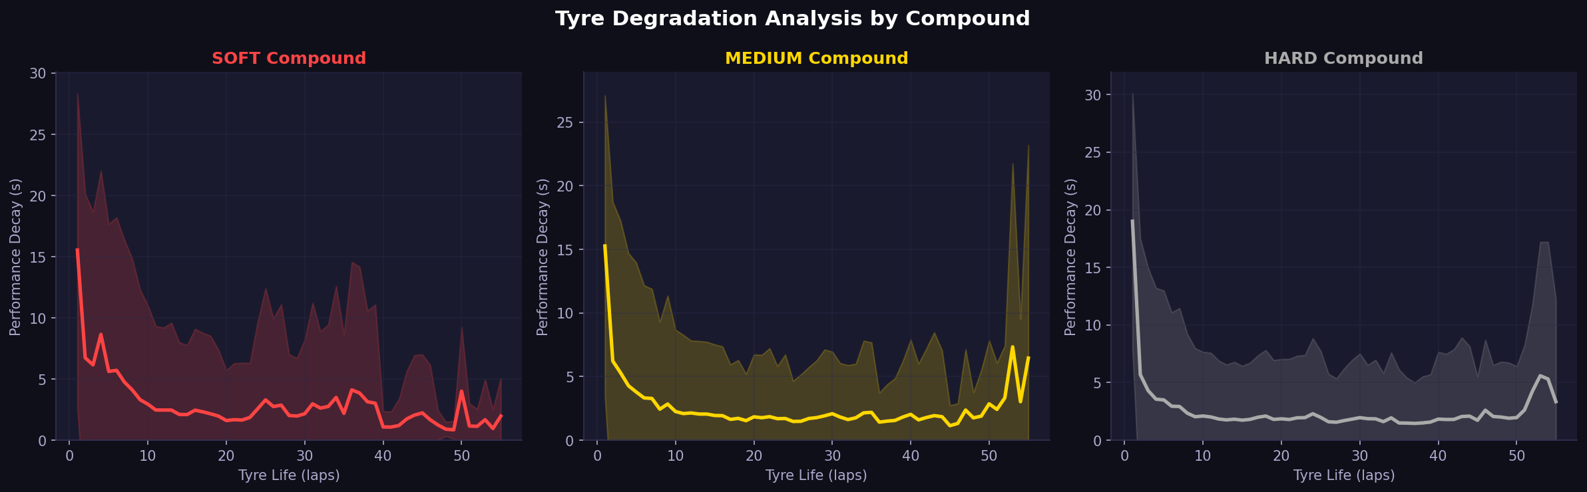
Figure 3: Tyre degradation curves by compound — mean performance decay (seconds lost vs best lap) over tyre life, with 1σ confidence band.

6.3 Team Risk Profiling — E[X] and Var(X)
For every pit stop event, TyreLife at pitting is recorded. Grouping by team reveals strategy determinism (low variance = predictable pit windows) vs opportunism (high variance = Safety Car reactive).
Team | Mean TyreLife E[X] | Variance Var(X) | Strategy Profile
Ferrari | 19.3 laps | 99.3 | Most deterministic — safety-first
Mercedes | 20.5 laps | 111.0 | Low variance — disciplined
Red Bull Racing | 19.7 laps | 116.6 | Moderate — balanced
Alpine | 18.7 laps | 134.2 | Moderate-high — reactive
Toro Rosso | 21.0 laps | 150.4 | High variance — flexible
Kick Sauber | 20.2 laps | 167.1 | Most opportunistic — reactive

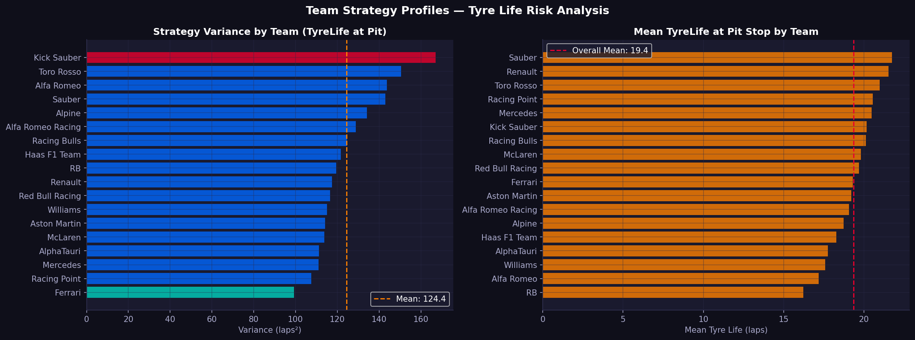
Figure 4: Team strategy profiles — pit stop timing variance (left) and mean tyre life at pit (right), ordered by risk profile.

6.4 Statistical Testing — Welch's T-Test
A Welch's T-Test (unequal variance) confirms a statistically significant difference in pace decay between high and low traffic pressure laps, validating traffic_pressure as a meaningful predictive feature beyond raw telemetry.

07 — Strategic Regression & Tactical Agility

7.1 Pit Duration vs Championship Points
Using the Ergast database, median pit stop duration is calculated per constructor across all recorded races. A Pearson correlation is computed against each team's total cumulative championship points, filtering to constructors with more than 100 career points. This tests whether operationally faster pit crews are associated with better championship results.

7.2 VSC Tactical Agility Score
For each driver in each race, VSC/SC deployments are detected from the Stochastic_Shock_VSC_SC flag and reaction time to pit response is measured. The mean reaction time (laps between VSC deployment and pit) forms the Agility_Score. Drivers who never pit under VSC receive a penalty score of 5.0 laps, reflecting missed strategic opportunity.

7.3 Random Forest Outcome Classifier
A Random Forest Classifier (100 estimators) is trained on four features to predict whether a driver finishes higher than their qualifying position:
Feature | Description | Expected Importance
GridPos | Starting grid position | Baseline — strong prior
Agility_Score | Mean laps to react to VSC | Strategic intelligence metric
PaceDecay | AR(1)-filtered pace degradation slope | Tyre management quality
Mean_Pit_Prob | Average BiLSTM pit probability across race | Model confidence signal

08 — Overtake Classification
The overtake_analysis.py module constructs lap-by-lap position matrices per race and scans all driver pairs for position swaps. Every detected swap is classified using two criteria:
- Strategic: Either driver pitted within ±2 laps of the overtake lap (HasPitStop = 1), OR either driver carried a PitStopProbability > 0.8 at the moment of the position change.
- On-Track: Neither condition satisfied — the position change was achieved through genuine track performance.
Analysis is restricted to position changes among the top 10 to reduce classification noise from retirements and DNFs.

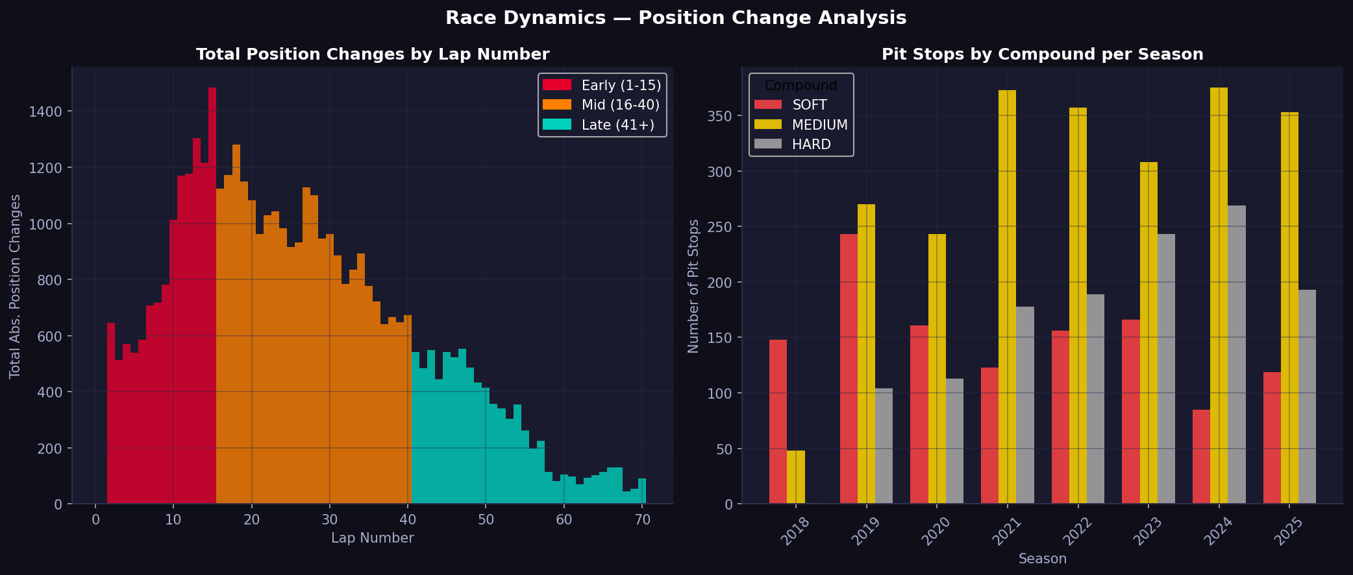
Figure 5: Race dynamics — position changes by lap phase (early laps in red, mid-race in orange, late in green) and pit stop counts by compound per season.

09 — Descriptive Analytics
The analyse.py module provides population-level statistics and visualisations across all aggregated race data (2018–2025):
Analysis | Key Finding
Lap Time Distribution | Mean: 89.6s — bimodal peaks reflect compound differences across circuits
Pit Lap Distribution | Mean pit lap: 27.7 — primary window concentrated laps 20–35
Tyre Life Distribution | Mean: 15.1 laps — SOFT compounds pit significantly earlier than HARD
Position Change Timing | Early laps (1–15) and mid-race (16–40) dominate net position changes
Class Imbalance | 4,818 pit events from 152,475 laps — 3.16% positive rate

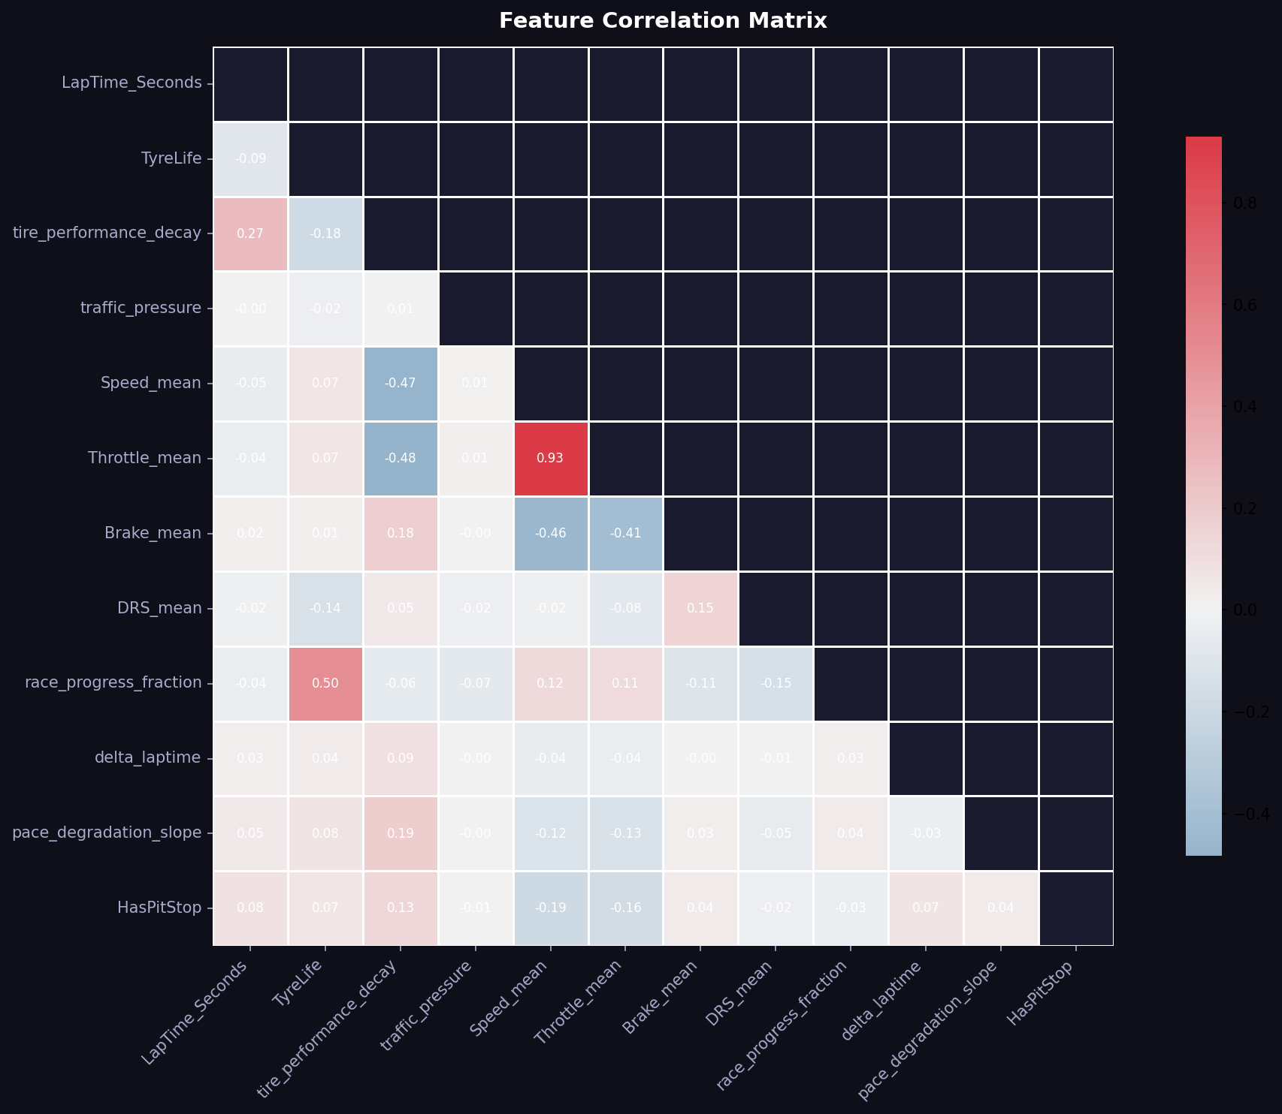
Figure 6: Feature correlation matrix — key relationships between engineered features and the HasPitStop target variable.

10 — Results & Key Findings

Model Performance
- BiLSTM model mean confidence on true pit laps: 83.8% — strong discriminative capability despite 3.16% positive class rate.
- Temporal train/test split (held-out 2025 season) ensures reported performance reflects genuine generalisation.
- Gradient clipping (max norm = 1.0) and ReduceLROnPlateau scheduling provided stable training convergence.

Strategic Insights
- Ferrari and Mercedes operate the most deterministic pit strategies (variance < 115 laps²), consistent with risk-averse championship infrastructure.
- Kick Sauber and Toro Rosso show the highest variance (>150 laps²), indicating reactive, opportunistic strategies that adapt to race conditions.
- The primary pit window centres on lap 27.7 — SOFT compounds pit ~8–10 laps earlier than HARD.
- Pit stop events are heavily concentrated in the first half of the race, consistent with one-stop strategies and undercut threats.

Statistical Validation
- Welch's T-Test confirms statistically significant pace decay difference under high vs low traffic pressure — validating traffic_pressure as a meaningful model feature.
- Pearson correlation analysis links median pit stop duration to championship points — quantifying the value of operational execution speed.

11 — Suggested Improvements

Model Architecture
- Transformer / Attention: Replace or augment the BiLSTM stack with multi-head self-attention. Attention weights would reveal which historical laps the model prioritises, adding interpretability.
- Multi-task Learning: Add auxiliary output heads for tyre compound prediction and stint length regression alongside the pit stop binary head.
- Ensemble: Combine BiLSTM predictions with Cox Proportional Hazards baseline via a stacking meta-learner for improved calibration.

Data Enrichment
- Weather Data: Incorporate real-time weather (temperature, humidity, rainfall probability) to capture wet-weather strategy divergences.
- Live Pit Timing: Integrate actual pit stop duration data to model undercut risk based on competitor crew performance.
- Car Setup Data: Add downforce level and fuel load estimates to contextualise pace degradation more accurately.

Deployment
- Real-time Inference: Wrap the inference module in a streaming FastAPI service that updates PitStopProbability on each new lap completion.
- Strategy Simulator: Build a forward-simulation engine using BiLSTM probabilities to run Monte Carlo scenarios for the remaining race distance.
- Calibration: Apply Platt scaling or isotonic regression to calibrate raw sigmoid output probabilities to match empirical pit stop rates.

